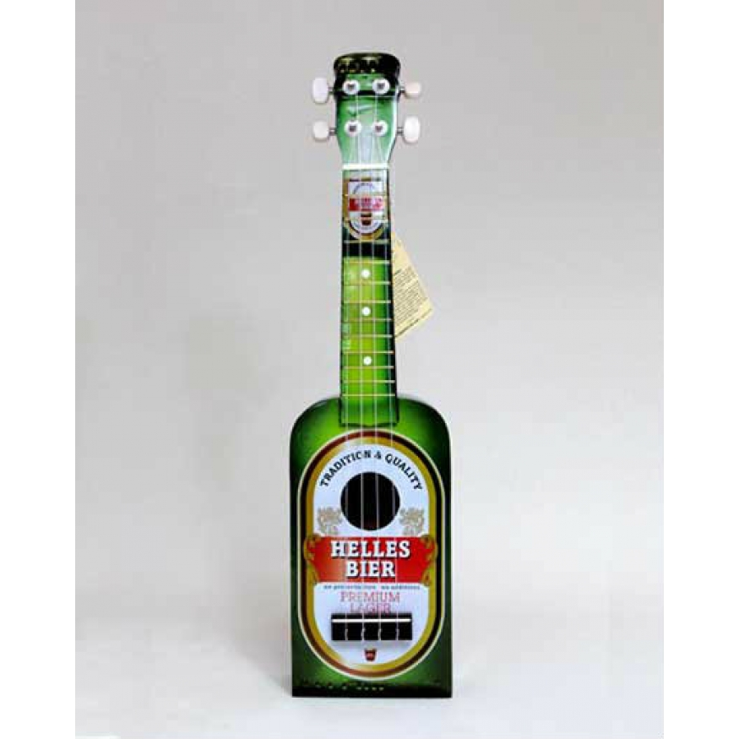
OLD STONE COTTAGE
BEERFEST 2017
F C
Spirits
F 2010
C 0003
Am 2000
G 0232
Em7 0202
I got guns in my head and they won't go
Am G
Spirits in my head and they won't go
F C
I got guns in my head and they won't go
Am G!
Spirits in my head and they won't

F C Am G F C Am G

[Verse]

C G F
I Been looking at the stars tonight
C G F
And I think oh how I miss that bright sun
C G F
I'll be a dreamer till the day I die
C G F
but they say oh how the good die young
Am
But were all strange
|G | |
and maybe we don't want to change

[Chorus]

F C
I got guns in my head and they won't go
Am G
Spirits in my head and they won't go
F C
I got guns in my head and they won't go
Em Am
Spirits in my head and they won't go
F C G
But the gun still rattles, the gun still rattles ohh
F C
I got guns in my head and they won't go
Am G
Spirits in my head and they won't go

C G F
I spend a lot of nights on the run
Spirits
F 2010
C 0003
Am 2000
G 0232
Em7 0202
C G F
and I think oh I'm lost and cant be found
C G F
I'm just waiting for my day to come
C G F
and I think oh I don't want to let you down
Am
cause something inside has changed
G
and maybe we don't want to stay the same

[Repeat Chorus]

F C
And I don't want a never ending life
G Am
I just want to be alive while I'm here
F C
And I don't want to see another night
G Am
lost inside a lonely life while I'm here

F C
I got guns in my head and they won't go
Am G
Spirits in my head and they won't go
F C
I got guns in my head and they won't go
Em Am
Spirits in my head and they won't go
F C G
But the gun still rattles, the gun still rattles ohh
F C
I got guns in my head and they won't go
Am G
Spirits in my head and they won't go

|Am |G! ||

C E7 F G

C E7 F G C E7 F G
If there's someone you can live without, then do so.
C E7 F G C E7 F G
And if there's someone you can just shove out; do so.

Chorus:

C E7 F G
Yoko Ono
C 0003
E7 1202
F 2010
G 0232
Am 2000
You can be my Yoko Ono
C E7 F G
You can follow me wherever I go
C E7
Be my, be my,
F G C E7 F G
Be my Yoko Ono.

C E7 F G C E7 F G
Isn't it beautiful to see two people so much in love?
C E7 F G
Barenaked as two virgins hand in hand and hand and hand in C E7 F G
glove.
C E7 F G
Now that I'm far away it doesn't seem to me to be such a
C E7 F G
pain.
C E7 F G
To have you hanging off my ankle like some kind of ball
C E7 F G
And chain.

[Repeat Chorus]

F G C Am
Oh no, here we go, our life is just one big pun.
F G C!
Oh no, here we go as Yoko sings

HOYLOHOYLOFGLDFJGDKLFGE!

C E7 F G
I know that when I say this, I may be stepping on pins
C E7 F G
and needles;
C E7 F
But I don't like all these people slagging her for
G C E7 F G
breaking up the Beatles. (Don't blame it on Yokey!)
C E7 F G
if I was John and you were Yoko, I would gladly give up
C E7 F G
musical genius,
C E7 F G C E7 F G
just to have you as my very own, personal Venus.

[Repeat Chorus]

C E7 F G
You can be my Yoko Ono
Yoko Ono
C 0003
E7 1202
F 2010
G 0232
Am 2000
C E7 F G
You can follow me wherever I go
C E7
Be my, be my,
F G C E7 F G
Be my Yoko Ono.

C E7
Be my, be my,
F G C E7 F G
Be my Yoko Ono.

C E7
Be my, be my,
F! G! C!
Be my Yoko Ono.

G C G Am
Ironic
G 0232
C 0003
Am 2000
Bb 3211
F△ 5500
An old man turned ninety-eight
G C G Am
He won the lottery and died the next day
G C G Am
It´s a black fly in your Chardonnay
G C G Am
It´s a death row pardon two minutes too late
G C G Am
Isn´t it ironic ... don´t you think

[Chorus]

G C G Am
It´s like rain on your wedding day
G C G Am
It´s a free ride when you´ve already paid
G C G Am
It´s the good advice that you just didn´t take
Bb F G
Who would´ve thought ... it figures

G C G Am
Mr. Play It Safe was afraid to fly
G C G Am
He packed his suitcase and kissed his kids good-bye
G C G Am
He waited his whole damn life to take that flight
G C
And as the plane crashed down he thought
G Am
" Well isn´t this nice ... "
G C G Am
And isn´t it ironic ... don´t you think

[Repeat Chorus]
Ironic
G 0232
C 0003
Am 2000
Bb 3211
F△ 5500

Fmaj7 G
Well life has a funny way of sneaking up on you
Fmaj7 G
When you think everything´s okay and everything´s going right
Fmaj7 G
And life has a funny way of helping you out when
Fmaj7
You think everything´s gone wrong and everything blows up
G
In your face

G C G Am
A traffic jam when you´re already late
G C G Am
A no-smoking sign on your cigarette break
G C G Am
It´s like ten thousand spoons when all you need is a knife
G C
It´s meeting the man of my dreams
G Am
And then meeting his beautiful wife
G C G Am
And isn´t it ironic ... don´t you think
G C G Am
A little too ironic ... and yeah I really do think ...

[Repeat Chorus]

Fmaj7 G
Life has a funny way of sneaking up on you
Fmaj7 G
Life has a funny, funny way ---
Fmaj7
of helping you out
G!
Helping you out

If I had $1M
G 0232
D 2220
C 0003
Em 0432

||:G |D |C | :||

G D C G
If I had a million dollars (If I had a million dollars)
G D C G
I'd buy you a house (I would buy you a house)
G D C G
If I had a million dollars (If I had a million dollars)
G D C
I'd buy you furniture for your house (Maybe a nice chesterfield or an
G
ottoman)
G D C G
And if I had a million dollars (If I had a million dollars)
G D C G
Well, I'd buy you a K-Car (A nice Reliant automobile)
G D C D
If I had a million dollars I'd buy your love

C D G ( G/F# ) Em C
If I had a million dollars, I'd build a tree fort in our yard
C D G ( G/F# ) Em C
If I had a million dollars, you could help, it wouldn't be that hard
C D G
If I had a million dollars
( G/F# ) Em C (strum once)
Maybe we could put a little tiny fridge in there somewhere
D (strum once)
You know, we could just go up there and hang out

||:G |D |C | :||

G D C G
If I had a million dollars (If I had a million dollars)
G D C G
Well, I'd buy you a fur coat (But not a real fur coat that's cruel)
G D C G
And if I had a million dollars (If I had a million dollars)
G D C G
Well, I'd buy you an exotic pet (Yep, like a llama or an emu)
G D C G
And if I had a million dollars (If I had a a million dollars)

G D C
Well, I'd buy you John Merrick's remains (Ooh, all them crazy elephant bones)

G D C D
And If I had a million dollars I'd buy your love

C D G ( G/F# ) Em C
If I had a million dollars, we wouldn't have to walk to the store
C D G ( G/F# ) Em C
If I had a million dollars, we'd take a limousine 'cause it costs more
C D G ( G/F# ) Em Dsus2(strum once)
If I had a million dollars, we wouldn't have to eat Kraft Dinner
D (strum once)
But we would eat Kraft Dinner
If I had $1M
G 0232
D 2220
C 0003
Em 0432

||:G |D |C | :||

G D C G
If I had a million dollars (If I had a million dollars)
G D C G
Well, I'd buy you a green dress (But not a real green dress, that's cruel)
G D C G
And if I had a million dollars (If I had a million dollars)
G D C G
Well, I'd buy you some art (A Picasso or a Garfunkel)
G D C G
If I had a million dollars (If I had a million dollars)
G D C G
Well, I'd buy you a monkey (Haven't you always wanted a monkey)
G D C D
If I had a million dollars, I’d buy your love

C D G ( G/F# ) Em C
If I had a million dollars, If I had a million dollars
C D G ( G/F# ) Em C
If I had a million dollars, If I had a million dollars
C D G ( G/F# ) Em D C
If I had a million dollars
D!
I'd be rich
G!
Strange Animal
Am7 0000
F9 0010
Em 0432
G 0232
Dm 2210
F 2010
D 2220

Am7 F9
Ahhhhhh... ah-ah ahh ah ahhh
Am7 F9
Ahhhhhh... ah-ah ahh ah ahhh (harp next slide!)

Am Em G
4 -4 5 -5 5 4 -4 5 -5 5 4 -4 -4 5 -5 5 4 -4 5 -5 5 4 -4
Am Em G
4 -4 5 -5 5 4 -4 5 -5 5 4 -4 -4 5 -5 5 4 -4 5 -5 5 4 -4

Am G Am G
Well they say I should approach you with caution but not to let you be aware of my fear
F Dm
Never know what you'll find don't understand your kind 'round
C F C F C F C F
here... Oh-oh

C F C F
Watching your moves they look so radical
C F C F
Hearing your words they sound fanatical
D G D G
Something inside reveals you're magical
F
Oh-ohhhhhh.... how can I get enough?

Am Em G
You're a strange animal that's what I know
Am Em G
But you're a strange animal I've got to follow
C F C F C F C F
Oh-oh
Am G
They've been trying to stick a line in your system
Am G
analysing the defenses you hold
F Dm
Trying to open wide hoping to step inside your
C F C F C F C F
soul... Oh-oh
C F C F
Strange Animal
Am7 0000
F9 0010
Em 0432
G 0232
Dm 2210
F 2010
D 2220

But everything here is unfamiliar
C F C F
Nothing they've seen remotely similar
D G D G
How can it be you're so peculiar
F
Oh-ohhhhhh.... how can I get enough?

Am Em G
You're a strange animal that's what I know
Am Em G
But you're a strange animal I've got to follow oh-oh oh-oh

Am7 F9 Am7 F9
Ahhhhhh... ah-ah ahh ah ahhh ahhhhhh... ah-ah ahh ah ahhh
Dm F F!
Ah-ah-ah Ah-ah-ah ah-ah
N/C
How can I get enough?
HIT! HIT!

Am Em G
You're a strange animal that's what I know
Am Em G
But you're a strange animal I've got to follow
Am Em G
You're a strange animal that's what I know
Am Em G
But you're a strange animal I've got to follow (HARP AHEAD!)

Am Em G
4 -4 5 -5 5 4 -4 5 -5 5 4 -4 -4 5 -5 5 4 -4 5 -5 5 4 -4
O Ominous Spiritus!
Am Em G
- -4 5 -5 5 4 -4 5 -5 5 4 -4 -4 5 -5 5 4 -4 5 -5 5 4 -4
Ahhhh!
C F C F C F C F C!

|D | |A | || 2x
D
I got my first real six-string
Summer of 69
D 2220
A 2100
Bm 4222
G 0232

A
Bought it at the five-and-dime
D
Played 'til my fingers bled
A
It was summer of '69

D
Me and some guys from school
A
Had a Band and we tried real hard
D
Jimmy quit and Jody got married
A
I shoulda known we'd never get far

Bm A
Oh when I look back now
D G
That was summer seemed to last forever
Bm A
And if I had the choice
D G
Ya - I'd always wanna be there
Bm A!
Those were the best days of my life
|D | |A | || 2x
D
Ain't no use in complainin'
A
When you got a job to do
D
Spent my evenin's down at the drive in
A
And that's when I met you, yeah!
{Chorus}
Summer of 69
D 2220
A 2100
Bm 4222
G 0232

Bm A
Standin on a mama's porch
D G
You told me that you'd wait forever
Bm A
Oh and when you held my hand
D G
I knew that it was now or never
Bm A!
Those were the best days of my life
D A D A
(Oh yeah)Back in the summer of 69’uh-huh
F Bb
Man we were killin' time
C
We were young and restless
Bb
We needed to unwind
F Bb C
I guess nothin' can last forever, forever no
D | |A | || 2x
D
And now the times are changin'
A
Look at everything that's come and gone
D
Sometimes when I play that old six-string
A
I think about ya wonder what went wrong
{Repeat Chrous} then |D |A ||
intro: C G D
Patio Lanterns
C 0003
G 0232
D 2220

riff: C G C G D x 2
C G C G D
Our house had the biggest patio
C G C G D C
Our house had all the summer shade...
C G C G D
We had patio lanterns
C G C G D
I'd spend half the night making lemonade
C G C G D C
Which we drank a lot 'cause we were all so shy...
C G C G D
Shy and nervous
{Chorus}
D C
Who was gonna be, who would be the first to dance
D C
Who was gonna be, who would be the first to kiss...
C G C G D
Under those patio lanterns
C G G! G! HIT! HIT!
D C G
Those patio lanterns they were the stars in our sky
D C G
Those patio lanterns, lighting up our lives
D C G
Those patio lanterns they were the stars in our sky
D C! C!
Those patio lanterns, lighting up our lives
C G C G D
Oh, those patio lanterns
Patio Lanterns
C 0003
G 0232
D 2220

C G C G D
C G C G D
And I was stuck on Joy, that was her name
C G C G D C
We didn't talk much, she was a nervous girl
(nervous girl)
C G C G D
I was a nervous boy
(nervous boy)
C G C G D
We stuck together like glue on glue
C G C G D C
Dancing to an old song, Bobby Vinton's Blue on Blue
(Blue on Blue)
C G C G D
Heartache on heartache
{Repeat Chorus}
riff: C G C G D x 2

D D2 D D-5
Ahead by a Century
D 2220
D2 2200
D-5 1220
C9 0203
A 2100
G 0232

D
First thing we’d climb a tree
and maybe then we’d talk
or sit silently, and listen to our thoughts
Cadd9
with illusions of someday
D
Casting a golden light
Cadd9
no dress rehearsal,
D
this is our life
||:D D2 D| D-5 :||
{Chorus}
D
that’s where the hornet stung me
Cadd9 D
and I had a feverish dream
Cadd9
with revenge and doubt
D
tonight, we smoke them out
A
You are ahead by a century,
G/B
you are ahead by a century, you are ahead
A
You are ahead by a century,
G! G! |G! ||

||:D D2 D| D-5 :||
D
Stare in the morning shroud , and then the day began
D
Ahead by a Century
D 2220
D2 2200
D-5 1220
C9 0203
A 2100
G 0232

I tilted your cloud, you tilted my hand
Cadd9
rain falls in real time
D
and rain fell through the night
Cadd9
no dress rehearsal,
D
this is our life
||:D D2 D| D-5 :||
{ Repeat Chorus}
||
A
You are ahead by a century,
G/B
you are ahead by a century, you are ahead
A
You are ahead by a century,
G! G! |G! ||
and disappointing you
||:D D2 D| D-5 :|| 4x
is getting me down!
D!

Am7 |A A7 A6 Am7:||
Courage
A 2100
A7 0100
A6 0120
C 0003
G 0232
D 2220

A
Watch the band through a bunch of dancers
C A A7| A6
Quickly, follow the unknown
Am7 A C G D
With something more familiar. Quickly something familiar

G D A
Courage, my word it didn't come it doesn't matter
Am7|A A7| A6 Am7|
A C G
Sleepwalk, so fast asleep in a motel
D A
that has the lay of home and piss on all of your
C G D
background and piss on all your surroundings
G D A
Courage, my word it didn't come it doesn't matter
G D A
Courage, my word it didn't come it doesn't matter
G D A
Courage, my word it didn't come it doesn't matter
G D! A!
Courage, it couldn't come at a worse………time
Am7|A! | Am7|A! | |

A! C!
Courage
A 2100
A7 0100
A6 0120
C 0003
G 0232
D 2220

So there's no simple explanation
G! |D |D2 D ||
for anything important any of us do
A! C! G! |D|D2 D |
and yea the human tragedy consisted of necessity
A C G D
of living with the consequences under pressure, under pressure.
A! C!
So there's no simple explanation
G! |D |D2 ||
for anything important any of us do
A! C!
and yea the human tragedy
G! |D |D2 ||
consisted of necessity
(gently, building)
A C
of living with the consequences
G D
under pressure, under pressure.

G D A
Courage, my word it didn't come it doesn't matter 3x
G D! |A.....(continue below)
Courage, it couldn't come at a worse time
Repeat ad naseum
||:…A | |C | | G | ||D
(last time) Am7||:A! | Am7:||A!
Am! G! C! F!
You'll have to excuse me, I'm not at my best
C! G! F! C!
I've been gone for a month, I've been drunk since I left
Am! G! C! F!
These so-called vacations will soon be my death
Home for a Rest
Am 2000
G 0232
C 0003
F 2010
Dm 2210
Em7 0202

C! G! F! C!
I'm so sick from the drink I need home for a rest.

Am G C F
We arrived in December and London was cold
C G |F | |
We stayed in the bars along Charing Cross Road
Am G C F
We never saw nothin' but brass taps and oak
C G F G
Kept a shine on the bar with the sleeves of our coats

{Chorus}
G! C! G!
You'll have to excuse me, I'm not at my best
C F
I've been gone for a week
|G | |
I've been drunk since I left
G! C! G!
And these so-called vacations Will soon be my death
C F G C
I'm so sick from the drink I need home for a rest Take me home....
Am |Dm |G |Em7 Am |Am |Dm |G |Em7 Am |
Home for a Rest
Am 2000
G 0232
C 0003
F 2010
Dm 2210
Em7 0202

Am G C F
Euston Station the train journey North
C G |F | |
In the buffet car we lurched back and forth
Am G C F
Past old crooked dykes through Yorkshire's green fields
C G F G
We were flung into dance as the train jigged and reeled
{Repeat Chorus}
||:Am |Dm |G |Em7 Am | Am |Dm |G |Em7 Am :|Em7| ||
Am G C F
By the light of the moon, she'd drift through the streets
C G |F | |
A rare old perfume, so seductive and sweet
Am G C F
She'd tease us and flirt, as the pubs all closed down
C G F G
Then walk us on home and deny us a round
{Repeat Chorus}
|Am |Dm |G |Em7 Am |Am |Dm |G |Em7 Am |
Am G C F
The gas heater's Empty, it's damp as a tomb
C G |F | |
The spirits we drank now ghosts in the room
Am G C F
I'm knackered again, come on sleep take me soon
C G F G
And don't lift up my head 'till the twelve bells at noon
{Repeat Chorus with outro chords}
Harvest Moon
D 2220
D6 2222
D△ 2224
G 0232
A 2100

D D6 D△ 4x
Em7 (Arp x2) D Riff x2
Come a little bit closer, hear what I have to say.
Em7 (Arp x2 )
Just like children sleepin,
D Riff x2
we could dream this night away.
G D Riff x2
But there’s a full moon risin’, lets go dancin in the night
G
We know where the music’s playin,
D Riff x2
Let’s go out and feel the night
G A Because I'm still in love with you,

I wanna see you dance again
G A D riff x 4
Because I'm still in love with you. on this harvest moon.
Em7 ARP x2

Harvest Moon
D 2220
D6 2222
D△ 2224
G 0232
A 2100

D Riff x2
When we were strangers I watched you from afar.
Em7 ARP x2 D Riff x2
When we were lovers I loved you with all my heart.
G D Riff x2
But now it's gettin late and the moon is climbin high.
G D Riff x2
I wanna celebrate, see it shinin in your eye.
G A Because I'm still in love with you,
G
I wanna see you dance again
A D riff x 4
Because I'm still in love with you. on this harvest moon.
[Harmonica solo]
|G | |D with riff 2x | |
|G | |D with riff 2x | ||
G A Because I'm still in love with you,
G
I wanna see you dance again
A D riff x 4
Because I'm still in love with you. on this harvest moon.
D!
